2|12
Java 8 features:
- Functional Interface
- Lambda Expression
- Method Reference
- Stream API
- Date & time
- Optional class
Before java 8 features java has a programming language focus on object-oriented programming approach but after the revolutionary realise of java 8 feature it also become functional oriented language.
Note- The main feature of java 8 is functional Interface.
- Functional Interface
Any interface having a single abstract method is known as functional Interface. It may contain object class methods, and default or static methods. We can also annotate an interface with @Functional Interface
- Lambda Expression (to use lambda expression, functional interface is mandatory)
Lambda Expression is used as short hand notation for implementing the abstract method of functional Interface
Syntax (parameters) -> {body};
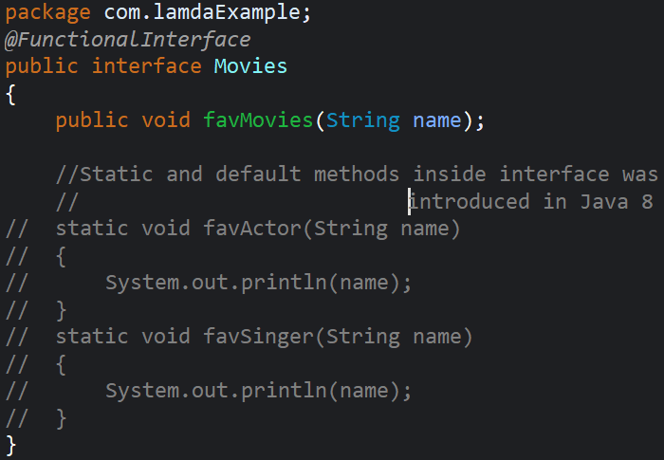
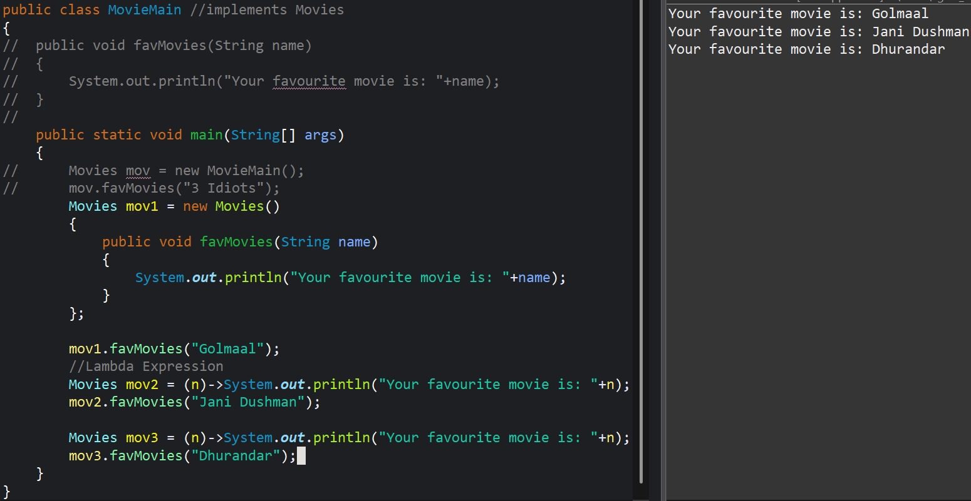
If we are using annotation then there is only one abstract method if we try to create two abstract methods then class name will have error as it is not a functional interface.
Static and default methods inside interface was introduced in java 8.
If there is single line then we do not need the curly bracket and not use return statement also.
If there are multiline then use curly bracts.
3|12
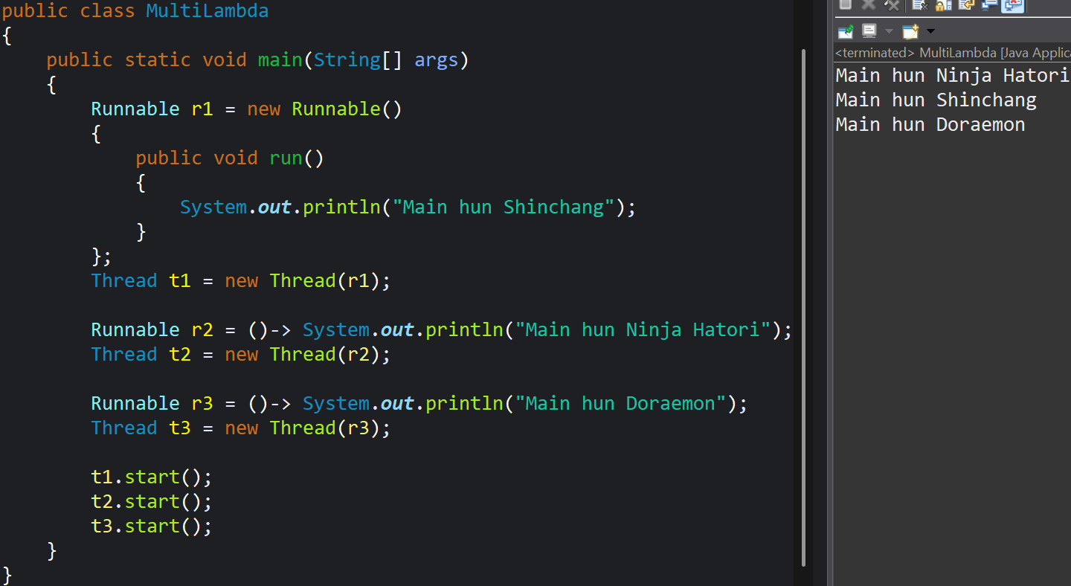

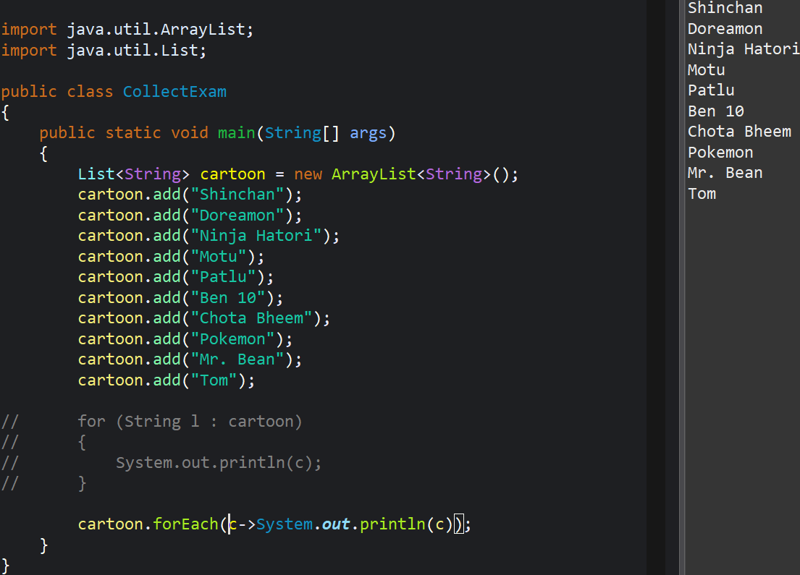

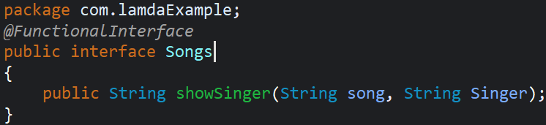
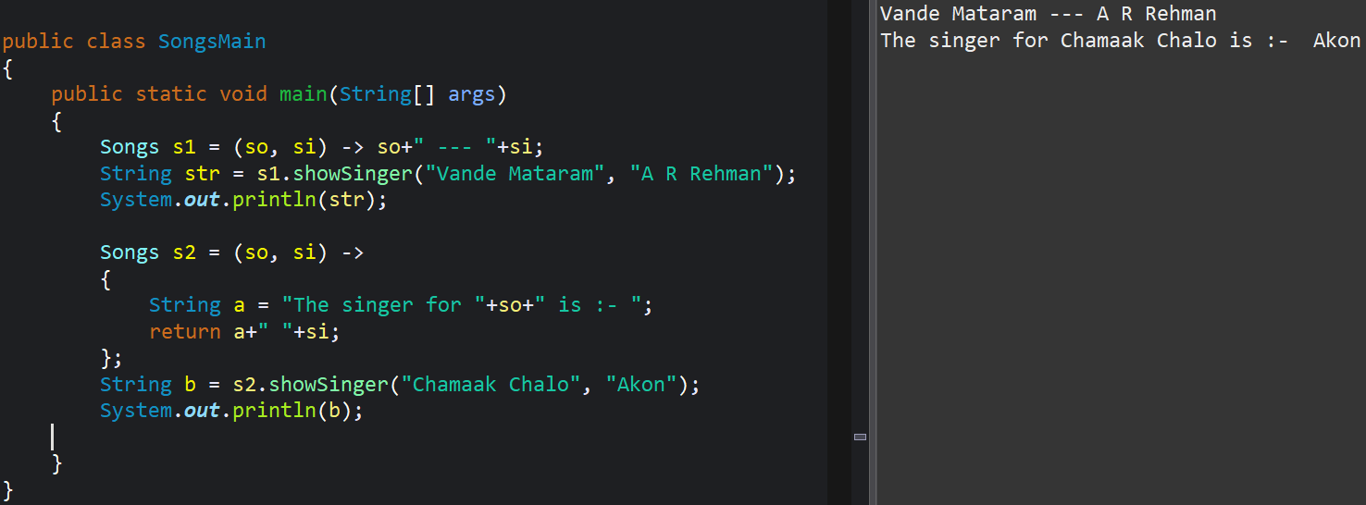
POJO -> Plain old java object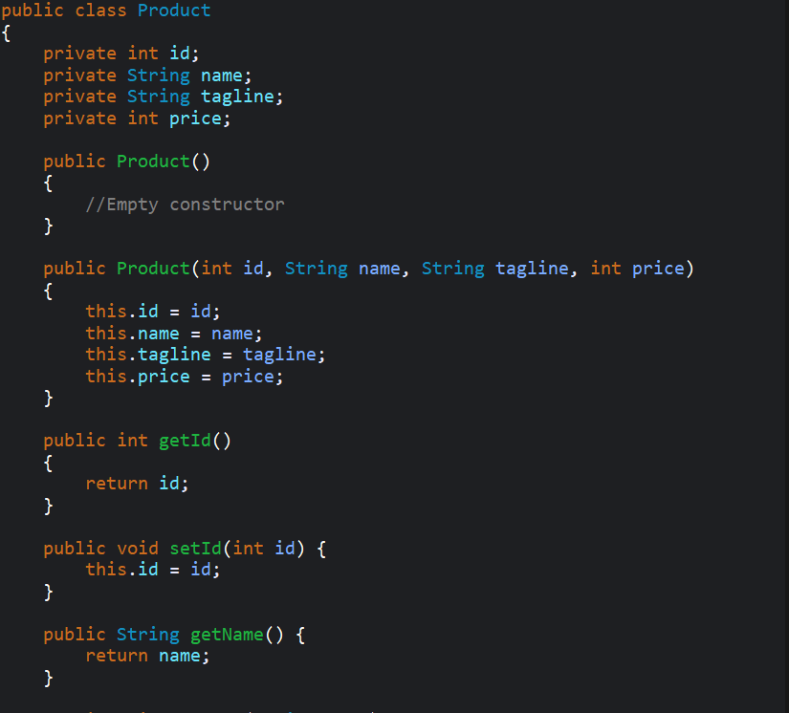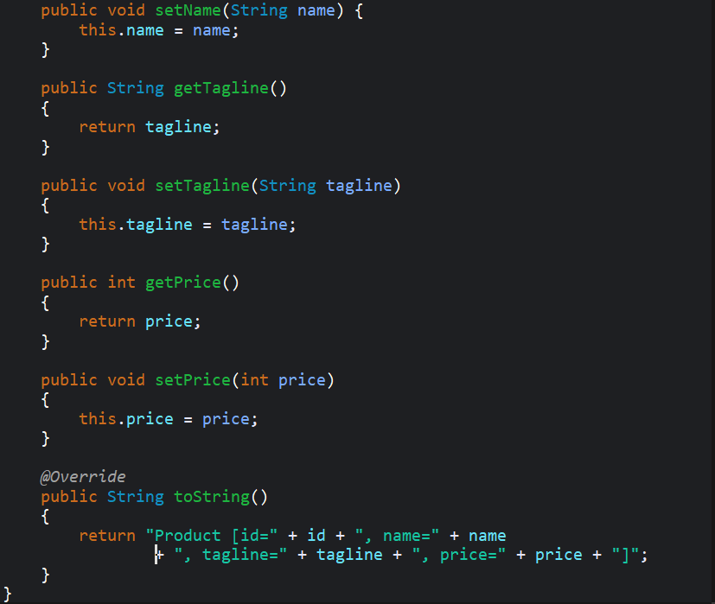

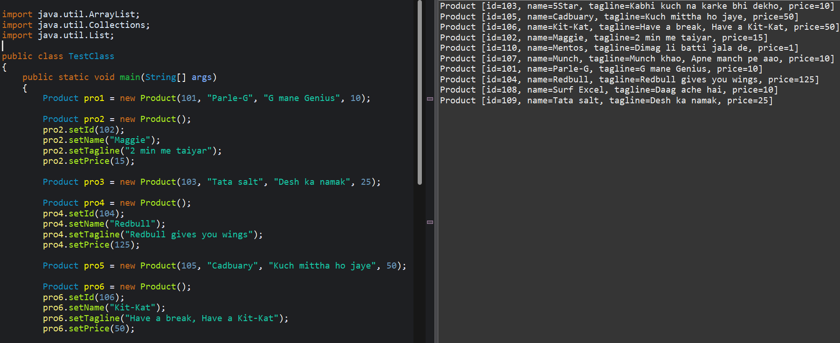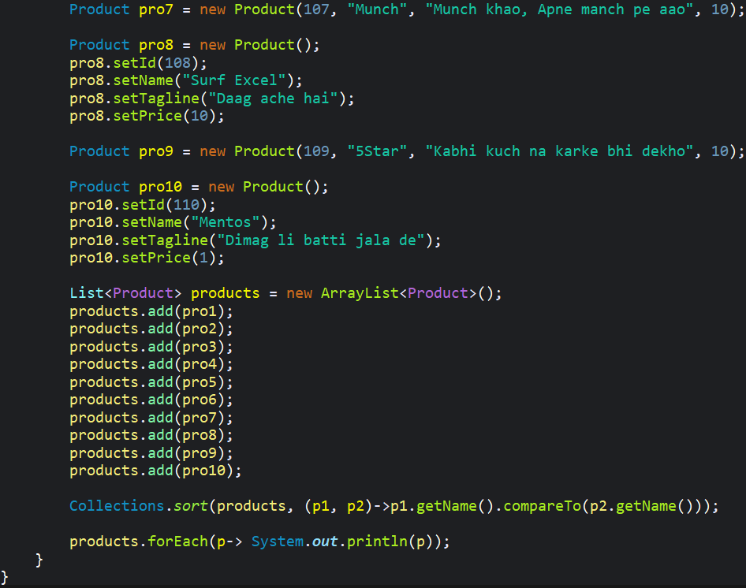

4|12

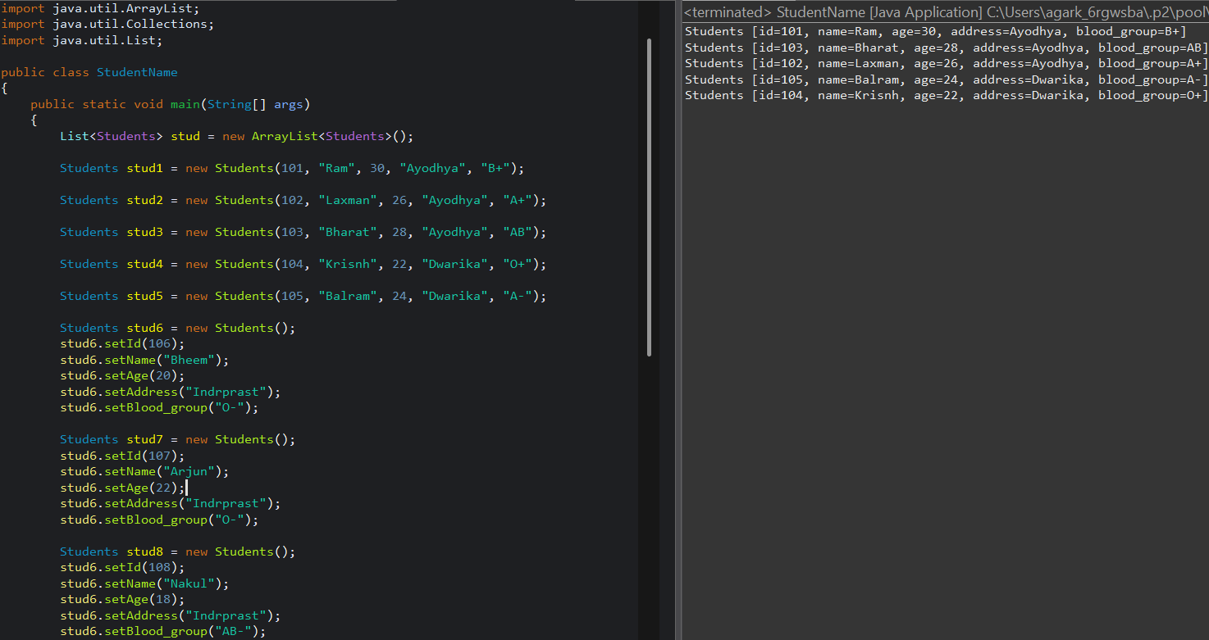

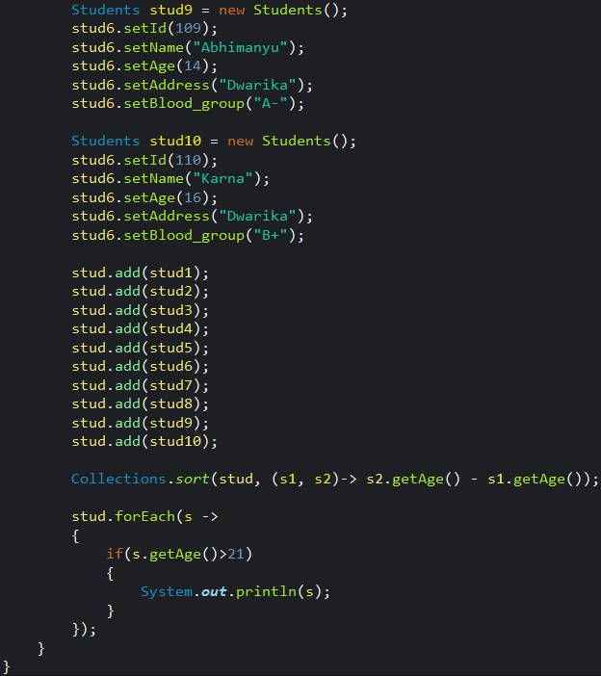

5|12
- Method referencing
Method referencing is the short hand notation for Lambda expression for calling any existing method.
It is of three types
- Static method referencing.
- Instance method referencing.
- Constructor referencing.
Syntax
Static class name :: Method name
Instance Object name :: Method name
Constructor Class name :: New
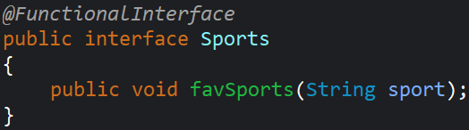
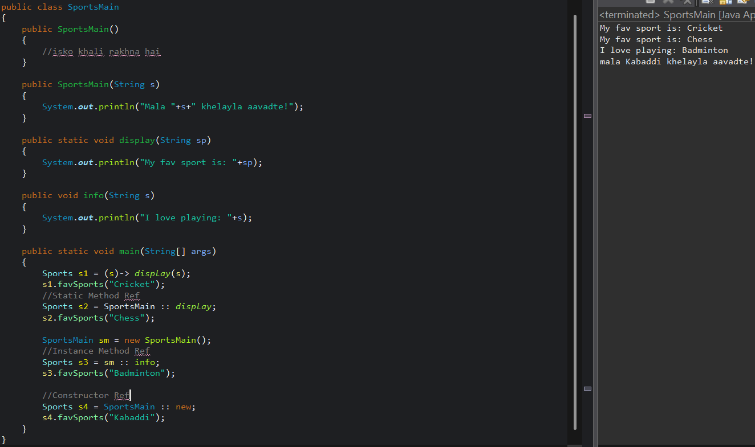

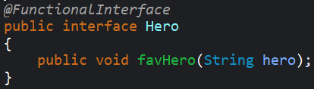
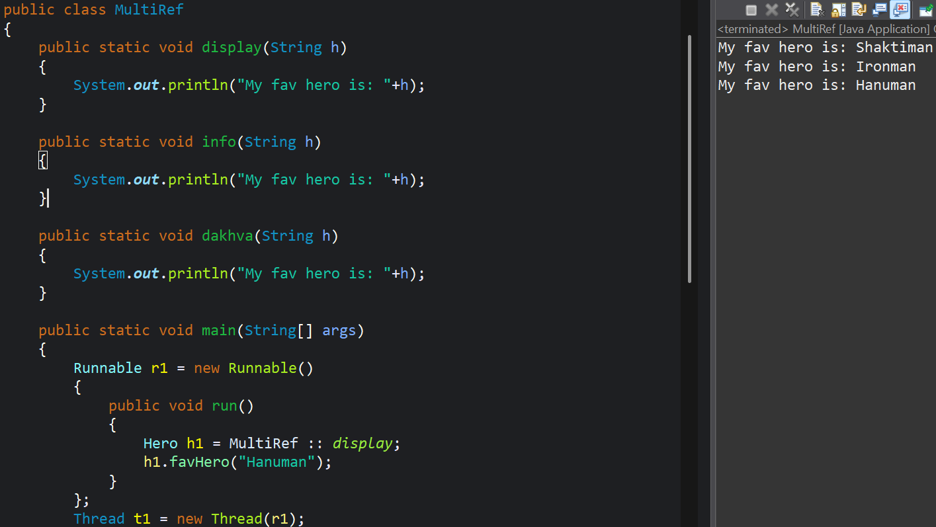
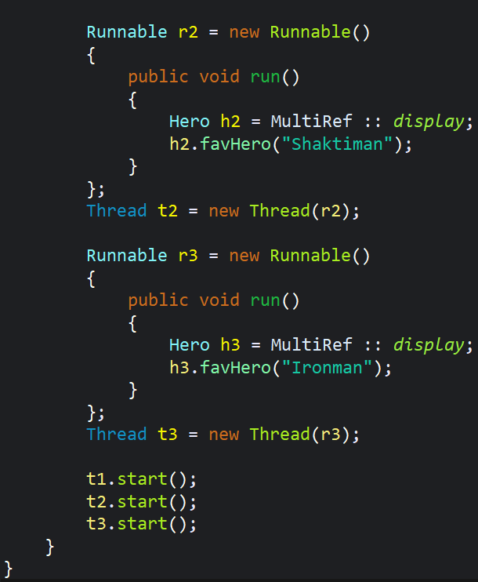

8|12
Pre-defined Functional Interface
Supplier | Consumer | Predicate | Function
get()  Return type  No parameter | accept()  No return type  One parameter | test()  Boolean return type  One parameter | apply()  Return type  One parameter

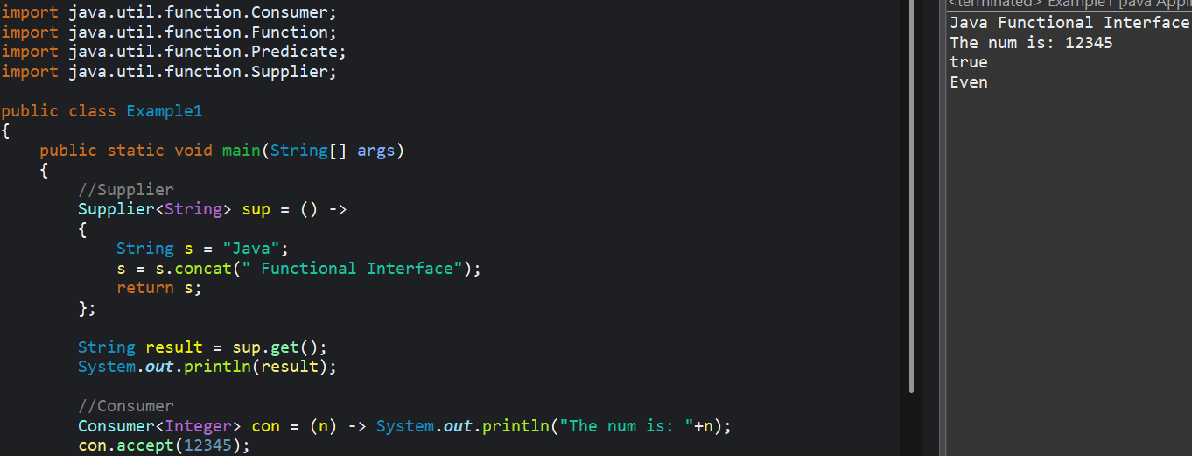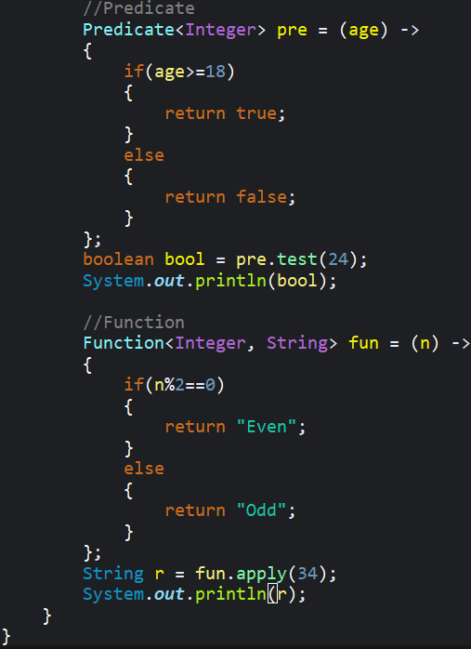
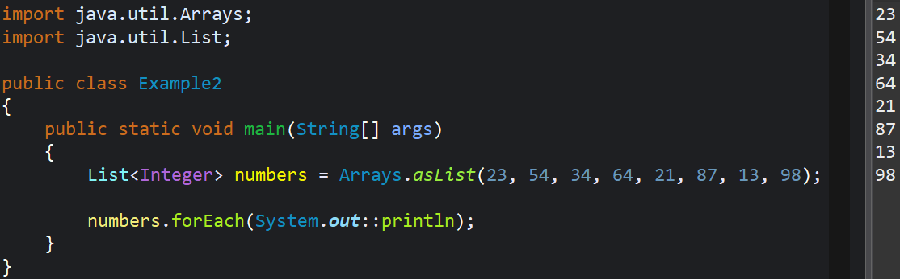
9|12
- Stream API
- Stream API in java 8 provides a functional programming approach to process collection of objects efficiently.
- It is used for filtering, mapping, reducing and collecting data in a declarative manner focusing on what to do rather than how to do it.
- Streams do not modify the original data they create new data structures making it immutable.
- Intermediate operations (it return a Stream)- These are lazy and not executed until a terminal operation is invoked.
Ex. Filter, Map, Sorted, etc.
- Terminal Operation (return result or side effect)- They are used to trigger Stream pipeline
Ex: forEach(), collect, iterate, count, reduce, etc.
- Once stream is consumed by terminal operation it cannot be reused hence you much create a new stream.
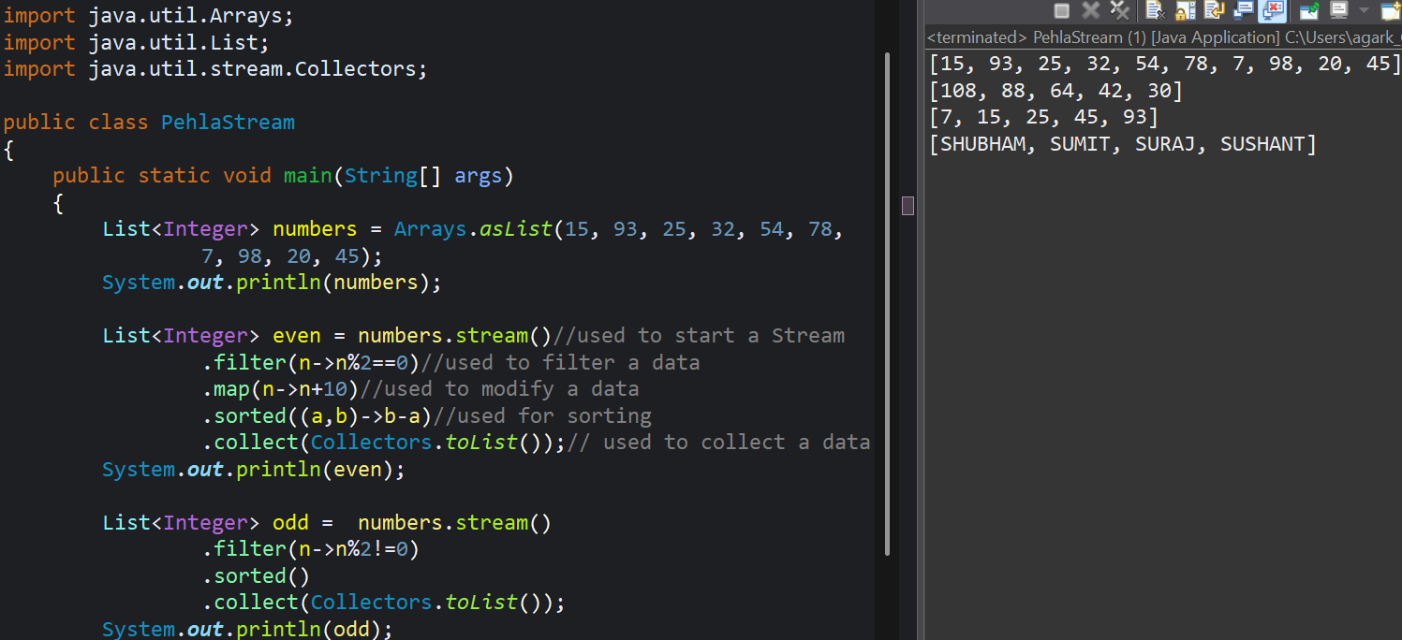
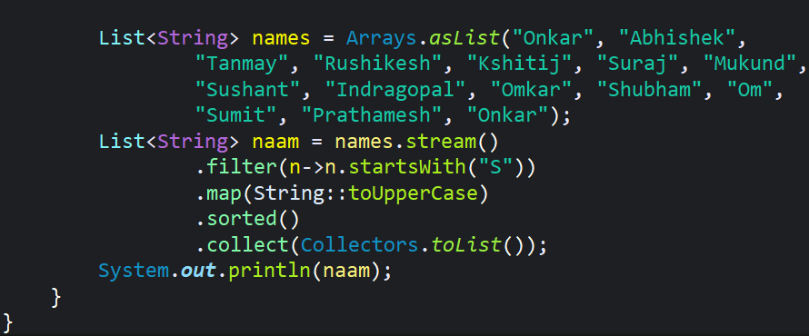

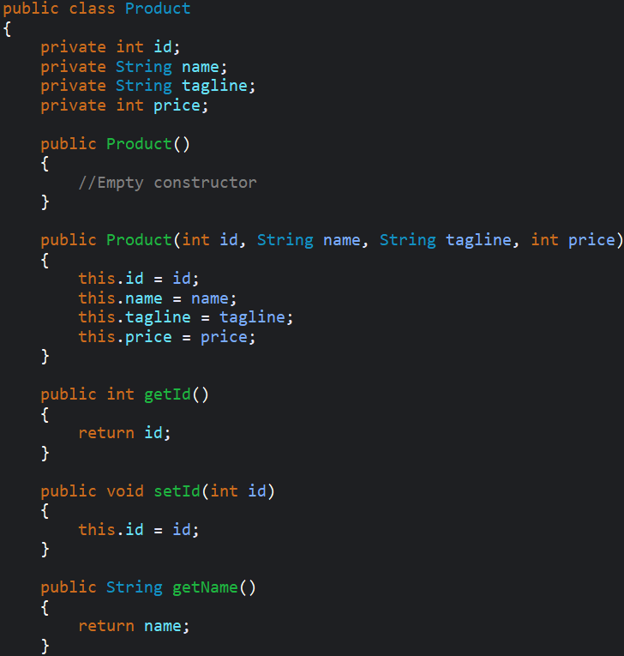
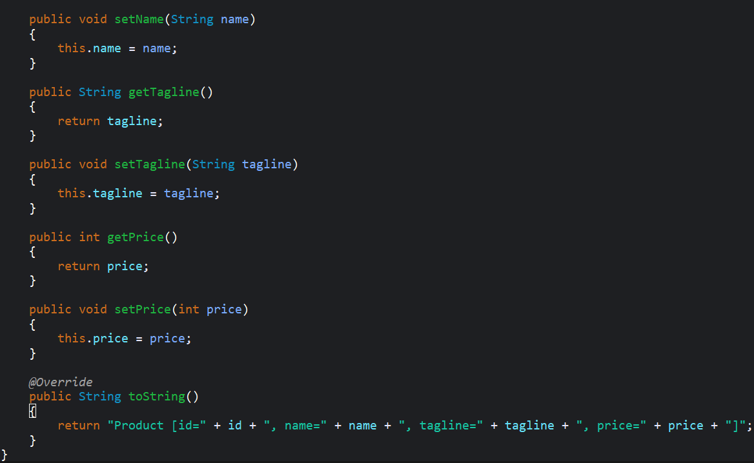
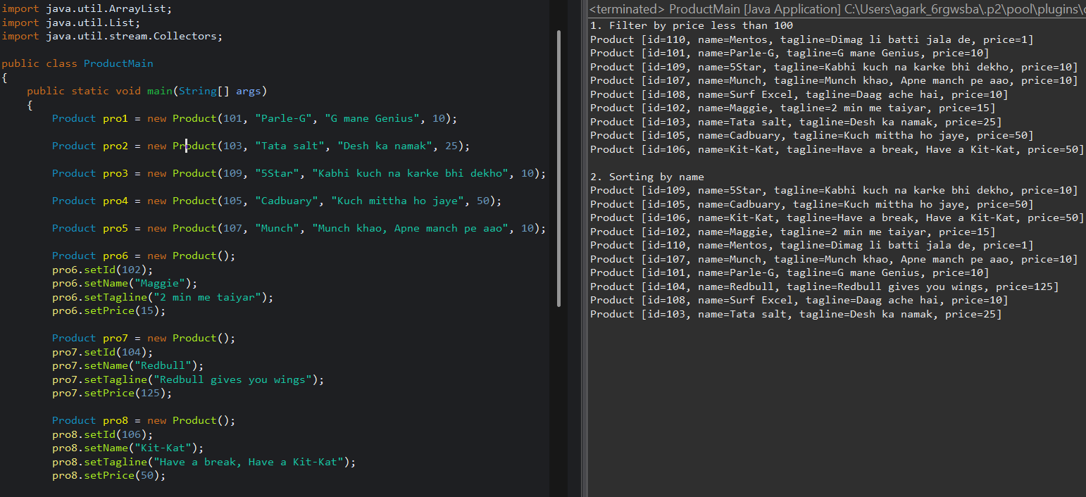
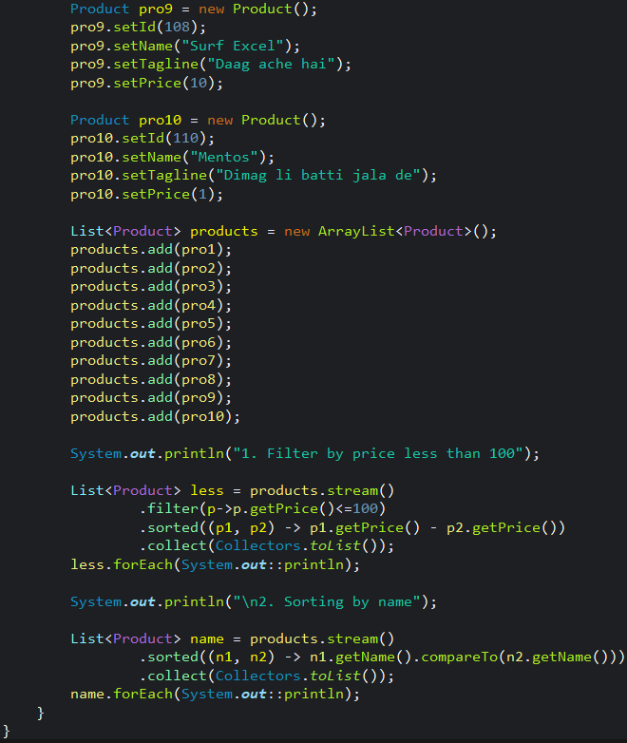

11|12
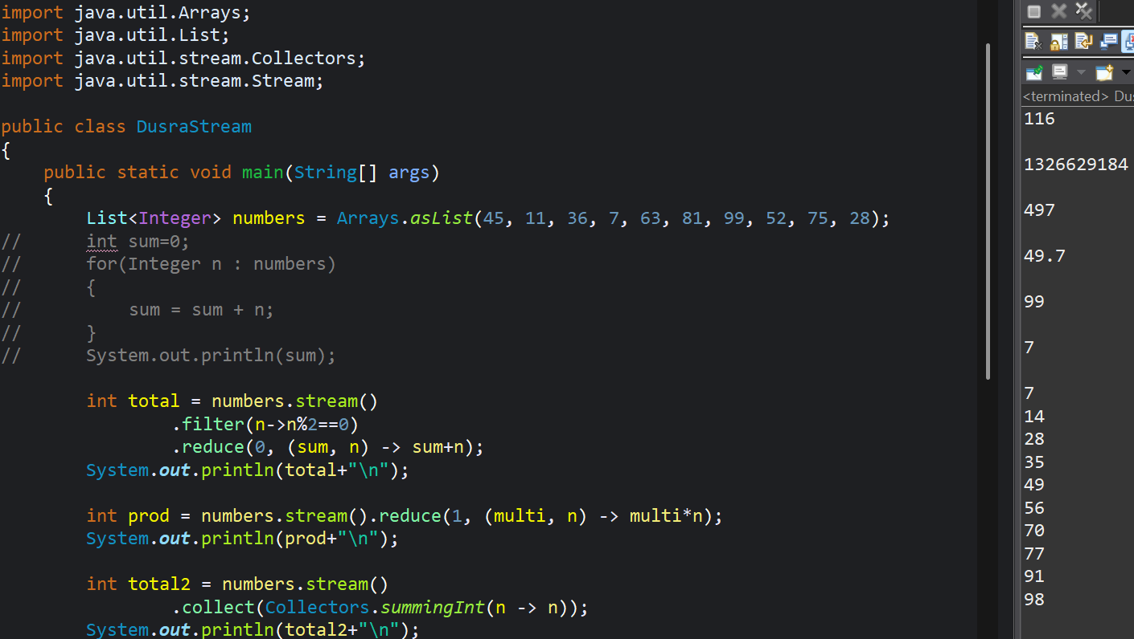
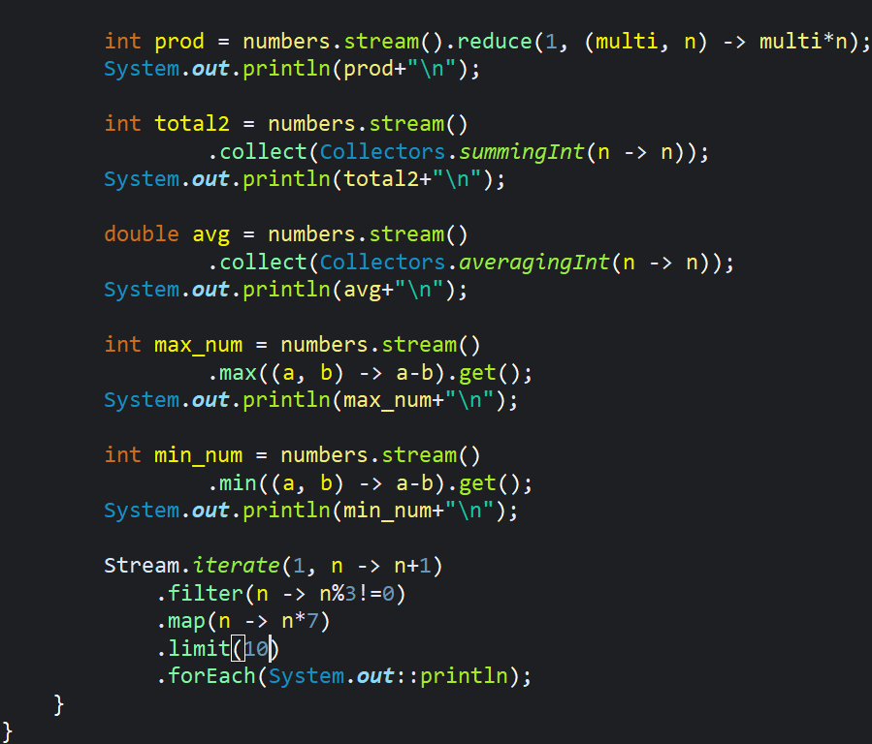
12|12
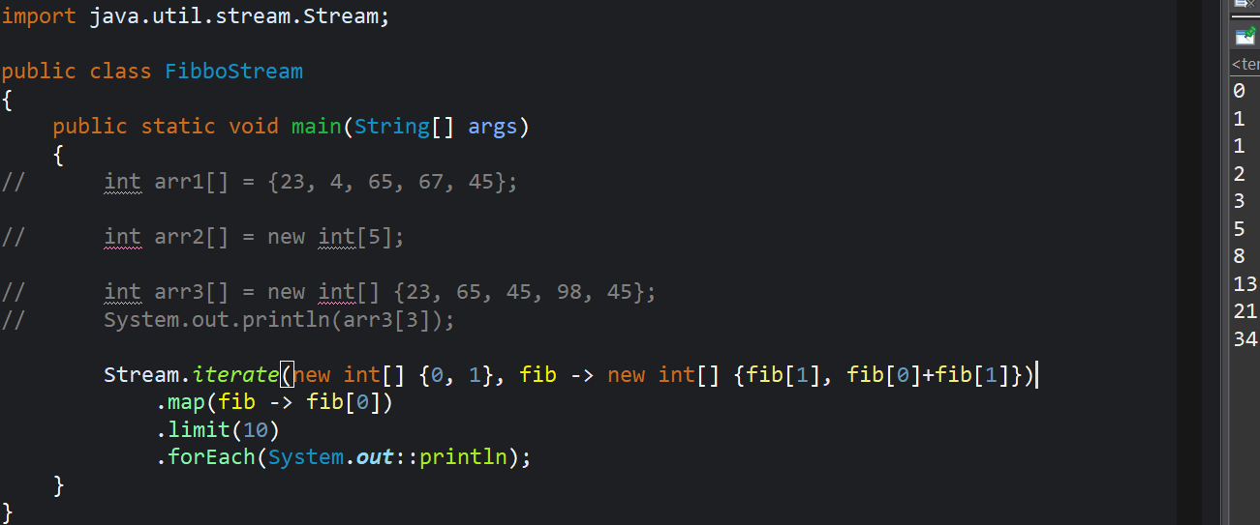
- Date & Time API
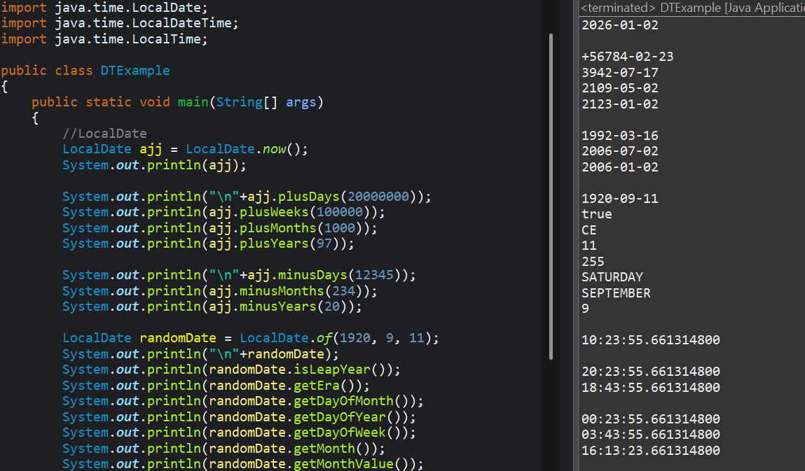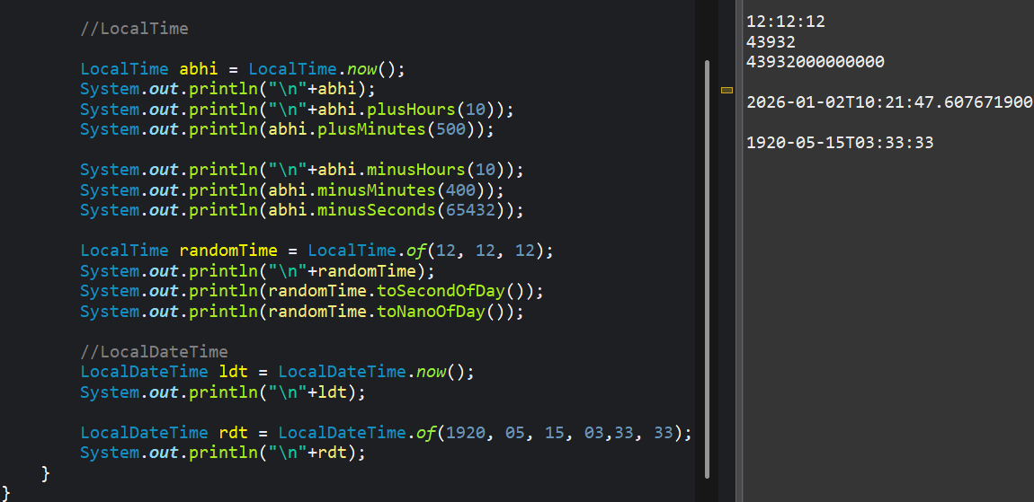

15|12
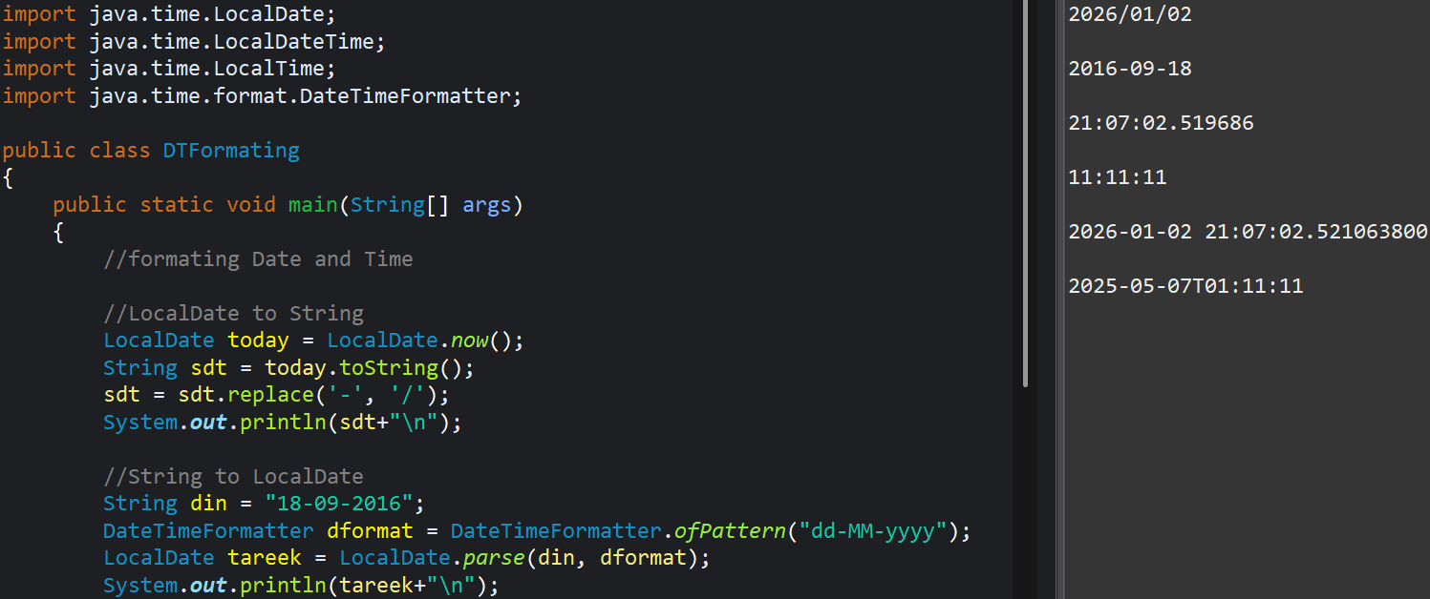
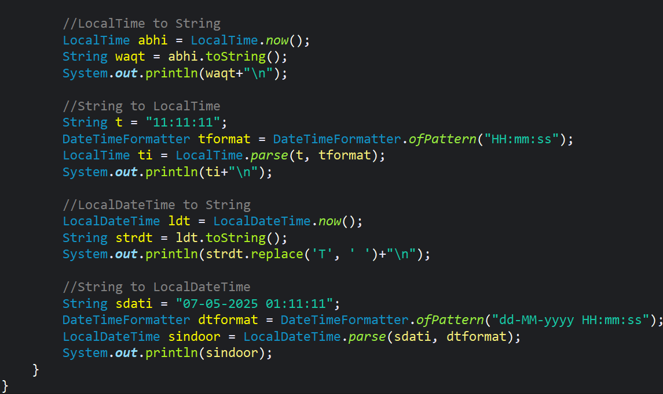

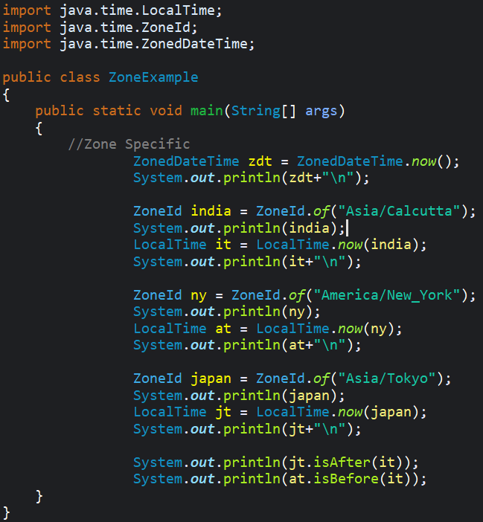 | 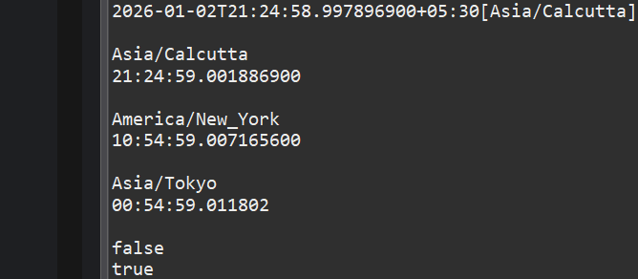

- Optional class was introduced in java 8 features to handle null values or null pointer exception in a better way.
